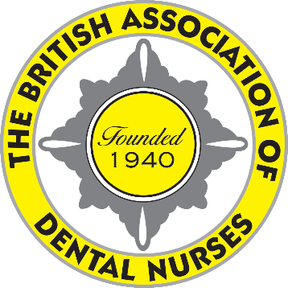
British Association
of Dental Nurses
Room 200, Hillhouse International Business Centre,
Thornton-Cleveleys, FY5 4QD
01253 338 365
pam@badn.org.uk
www.badn.org.uk
Chief Executive
PAMELA A SWAIN
MBA LCGI FIAM FCMI

18 March 2022

BADN LAUNCHES MENOPAUSE POLICY

PRESS RELEASE
For immediate release

BADN, the UK’s professional association for dental nurses, has today launched its Menopause Policy.

Women over 50 are the fastest growing segment of the workforce – and dental nursing is 98% female. According to a leading HR company, one in four menopausal women consider leaving their job because of lack of support and understanding from employers or managers. Employers who do support their employees through the menopause will benefit from lower sicknex absence and employee turnover, as well as increased engagement and loyalty.

BADN President Jacqui Elsden said “Given the current recruitment/retention crisis in dental nursing, it is in the best interests of general dental practices to support their employees during this time – not to mention the fact that menopause related tribunals have doubled in recent years.

“However, BADN recognises that this is still a difficult subject for many people and many employers may not know how to broach this subject in their practice. We have therefore produced this advice sheet with lists of relevant legislation, useful articles/websites and a specimen policy to break this taboo.”

The advice sheet/policy is available on the BADN website www.badn.org.uk. Hard copies will be available on the BADN stand (A22) at Dental Showcase (ExCel London) on 25 and 26 March 2022.

-Ends-

Notes for Editors:
- BADN is the UK’s professional association for dental nurses. Founded in 1940, it represents the interests of dental nurses in discussions with the GDC, BDA and other professional associations, HMRC, and other relevant bodies.
- Membership is open to all dental nurses, working in all areas of dentistry. Full Membership is open to all Registered Dental Nurses and costs £50pa (currently reduced to £35). Student Associate membership is open to all student dental nurses and costs £10pa. Associate Membership is open to all retired, former and overseas dental nurses.
- Full Members are able to benefit from special BADN member rates on professional indemnity cover. All members have access to the members only area of the BADN website, www.badn.org.uk, with information and advice; the free Legal Helpline; the Health & Wellness Hub with counselling/support helpline; the quarterly digital “British Dental Nurses’ Journal” with free CPD; special rates at the National Dental Nursing Conference and other BADN events; and BADN Rewards, which offers a wide range of special offers and discounts on shopping, insurance, lifestyle, travel and much more.
- Dental nurses can join their professional association at www.badn.org.uk.
- A specimen copy of the Policy is attached below for information purposes only. Please do NOT include this when publishing this Press Release on line or in publications – please direct readers to the BADN website www.badn.org.uk where it may be downloaded.

