STANDARD FURNITURE
BOOKING FORM

Company Name
Address
Postcode
Telephone
Contact Name
Contact E-mail
Purchase Order No.

STANDARD FURNITURE | QTY | TOTAL
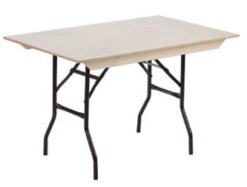  6ft Trestle Table  £25.00 each |  | £
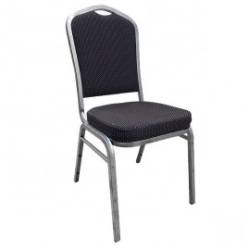  Grey Fabric  Conference Chair  £12.00 each |  | £
ALL PRICES ARE SUBJECT TO VAT |  | £

ADDITIONAL FURNITURE
Additional furniture is available to hire through our official contractor Europa International https://www.europainternational.com

INVOICE ADDRESS (if different from above)

Company Name
Address
Postcode
E-mail

