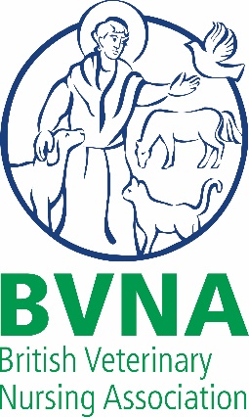
Help in the Community Award Terms and Conditions

- All entries must be submitted using the online Nominations form.
- Deadline for entries midday 25 September
- The awards nominations are free to enter, and there is no limit to the number of nominations that can be submitted. Please complete and upload a separate entry form for each nomination you wish to submit.
- Please ensure that you read the criteria for the categories that you are entering people for, and check that your entry complies with them.
- We recommend that you include as much information as possible into your entry form within the word limits. The more information that you provide, the easier it will be for our judges to consider your nominee.
- Use of Information. Please note that we will contact all Individuals nominated to obtain their agreement that we may share the information provided by you and them, with our employees, officers, representatives, the Judges and sponsors (if applicable), in connection with the administration of the awards and the aims and objectives.
- Nominators. BVNA Members, non-members, Veterinary Surgeons and members of the public.
- Nominees. RVNs, student nurses, nursing assistants, receptionists. All nominees will be sent a certificate in recognition of their nomination.
- Finalists. Three finalists in each award category will be chosen and invited to attend our Virtual Awards Night at (time TBC) on (date TBC). In order to take part finalists will be asked to film a short, pre-recorded video to be played during the event.
- Filming and Photography. We may, at our discretion, choose to photograph, film, record and/or broadcast the Awards Night and associated events. We will ask the Individual being nominated to grant us permission to use any relevant name/s, voice/s, likenesses, images, statements and contributions made by them at or in connection with the awards event, in any and all media (whether now known or hereinafter invented) throughout the world and in perpetuity. All such material shall be retained for an indefinite period for these purposes.
- The judges’ decision is final and no correspondence or discussion will be entered into or feedback given regarding the selection of shortlisted nominations or winners.
- Existing BVNA Council Members and incoming Council Members are not eligible for nomination AND are not eligible to nominate others in the BVNA Awards AND are not eligible to nominate others.

